Fraudulent Claim Detection – Report

**Group Members:**

* Anish Dhondi
* Ankit Shrivastava

## **🔎 1. Problem Statement**

Global Insure faces significant losses due to fraudulent insurance claims. The existing manual review process is inefficient and expensive. This project aims to build a machine learning model to identify potentially fraudulent claims early, enabling faster decisions and reduced financial risk.

## **2. Methodology Overview**

The solution followed a structured 8-step process:

1. **Data Preparation & Cleaning**
2. **Train-Validation Split (70:30)**
3. **Exploratory Data Analysis (EDA)**
4. **Feature Engineering**
5. **Model Building (Logistic Regression & Random Forest)**
6. **Cutoff Optimization**
7. **Validation Evaluation**
8. **Final Recommendation**

## **3. Data Cleaning Assumptions**

* Column **_c39** was dropped as it had 100% NULL values.
* 91 Rows with missing **authorities_contacted** values or NULL values were removed.
* **umbrella_limit** values with negatives (one row with value = -1,000,000) were removed as negative insurance coverrage did not make sense.
* **insured_zip** was dropped after realizing it offered very little value as the incident_city column is already there. Also with so many unique values, if considered, **insured_zip** column would have made hundreds of dummy variables and confusing the analysis.
* **incident_location** was dropped because all its values were unique and not contributing to model and analysis.
* **policy_number** was retained for a long time but later excluded from modeling since it's a unique ID and not useful for modelling.
* **policy_bind_date** and **incident_date** were dropped after deriving useful features (incident_month, incident_dayofweek, policy_bind_year) from them.

## **4. EDA & Feature Engineering Assumptions**

* capital-gains and capital-loss dropped due to low correlation with fraud.
* Rare values in insured_hobbies and insured_occupation grouped into "Other.
* Created new features: policy_bind_year, incident_month, incident_dayofweek, injury_ratio, property_ratio, vehicle_ratio.
* Dummy variables created for categorical columns
* MinMax scaling applied to numerical features.
* Class imbalance handled using RandomOverSampler.

## **5. Key Insights from EDA**

**CATEGORICAL VARIABLES**

|  |  |  |  |  |
| --- | --- | --- | --- | --- |
| **Category** | **Feature** | **Value(s)** | **Fraud Likelihood (%)** | **Interpretation** |
| High Fraud Likelihood | insured_hobbies | chess, cross-fit | 80.6%, 76.0% | Very high fraud rates; strong indicators of possible fraud |
| High Fraud Likelihood | incident_severity | Major Damage | 58.40% | Claims reporting major damage are highly suspicious |
| High Fraud Likelihood | auto_model | Silverado, ML350, C300 | 53.8%, 46.7%, 46.2% | Certain high-end models show strong fraud patterns |
| High Fraud Likelihood | insured_education | MD, JD, PhD | 33.3%, 29.3%, 29.2% | Higher degrees correlate with increased fraud rates |
| High Fraud Likelihood | insured_occupation | farming-fishing, exec-managerial | 38.7%, 37.0% | Fraud more likely in specific occupations |
| High Fraud Likelihood | auto_make | Mercedes, Ford, Audi | 39.6%, 35.0%, 33.3% | Certain car brands see higher fraud frequencies |
| High Fraud Likelihood | authorities_contacted | Other, Fire | 33.6%, 29.1% | Unusual authority contact types linked with more fraud |
| High Fraud Likelihood | incident_state | OH, SC | 50.0%, 32.7% | Certain states report significantly more fraud |
| High Fraud Likelihood | collision_type | Rear, Front | 30.5%, 28.9% | Rear and front collisions are more associated with fraud |
| High Fraud Likelihood | insured_sex | MALE | 30.20% | Male policyholders show a higher fraud ratio |

**NUMERICAL VARIABLES**

|  |  |  |
| --- | --- | --- |
| **Feature** | **Insight** | **Indicator Strength** |
| Total Claim Amount | Higher in fraud cases (62K vs. 56K); strong and consistent difference. | Strong. Should be kept. |
| Injury Claim | Higher in fraud (8.5K vs. 8.0K); relevant and consistent. | Strong. Should be kept. |
| Property Claim | Higher in fraud (8.6K vs. 7.7K); noticeable impact. | Strong. Should be kept. |
| Vehicle Claim | Significantly higher in fraud (45K vs. 40K); key variable. | Strong. Should be kept. |
| Witnesses | Slightly more in fraud cases; may help support claims analysis. | Moderately Strong. Should be kept. |
| Bodily Injuries | Slight increase in fraud (1.07 vs. 1.01); mild | Moderately Strong. Should be kept. |
| Months as Customer | Slightly higher for fraud (212 vs. 200); trend is weak. | Moderately Strong. Should be kept. |
| Age | Almost equal in both groups (~39); not strong | Weak. Should be removed. |
| Policy Number | Randomly distributed; no signal expected. | Weak. Should be removed. |
| Policy Deductible | Almost identical across both groups. | Weak. Should be removed. |
| Policy Annual Premium | Very similar between groups (~1250); no clear difference | Weak. Should be removed. |
| Umbrella Limit | Mostly zero; heavy skew and no meaningful difference. | Weak. Should be removed. |
| Capital Gains | Similar means; no clear difference. | Weak. Should be removed. |
| Capital Loss | Very similar and heavily negative; not helpful. | Weak. Should be removed. |
| Incident Hour of the Day | Slightly earlier in fraud cases; slight pattern. | Moderately Strong. Should be kept. |
| Number of Vehicles Involved | Slightly higher in fraud; low variability overall. | Moderately Strong. Should be kept. |
| Auto Year | Almost identical means (2005); no usable variance. | Weak. Should be removed. |

## 

## **6. Model Building & Selection**

### **✅ Logistic Regression**

* **Feature Selection:** RFECV reduced variables to 7 final features:  
  + insured_hobbies_chess
  + insured_hobbies_cross-fit
  + insured_hobbies_video-games
  + incident_severity_Minor Damage
  + incident_severity_Total Loss
  + incident_severity_Trivial Damage
  + auto_model_92x
* **Cutoff selected:** 0.4 based on sensitivity-specificity trade-off.
* **Scaling:** Applied MinMax scaler.

**Comparison Between Initial and Optimal Cutoff probabilities**

|  |  |  |
| --- | --- | --- |
| **Metric** | **Cutoff = 0.5 (Initial)** | **Cutoff = 0.4 (Optimized)** |
| Accuracy | 0.8594 | 0.8680 |
| Sensitivity | 0.8970 | 0.9249 |
| Specificity | 0.8219 | 0.8112 |
| Precision | 0.8343 | 0.8304 |
| F1 Score | 0.8645 | 0.8751 |

### **Why is optimal cutoff probability = 0.4?**

* Balances **high sensitivity (0.9249)** with good specificity (0.8112); better fraud detection than default 0.5 cutoff.

### **ROC Curve -**AUC = **0.8855**; steep rise near Y-axis shows strong performance even at lower thresholds.

### **Cutoff vs Metrics Plot -**At **0.4**, sensitivity and specificity are well-balanced; recall drops sharply beyond 0.7

### **Precision-Recall Curve -**At 0.4, both **precision (0.8304)** and **recall (0.9249)** are high ideal for minimizing false negatives.

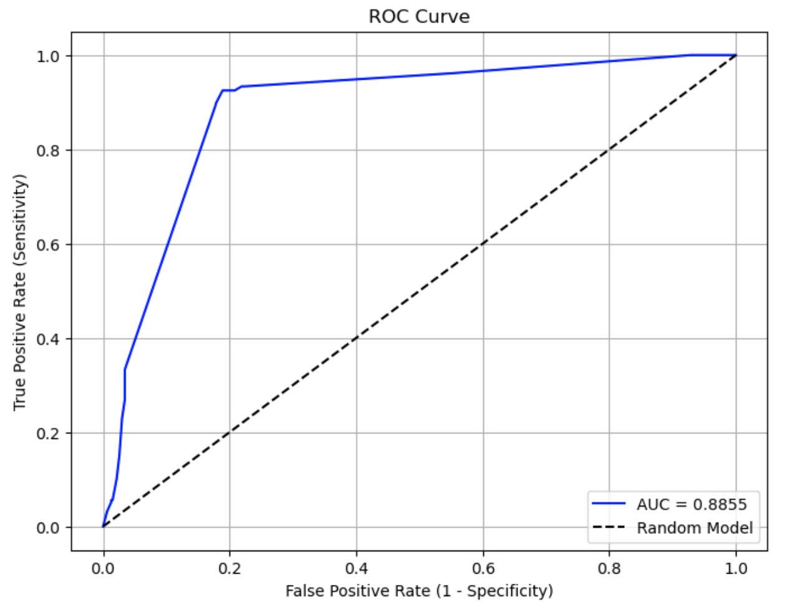

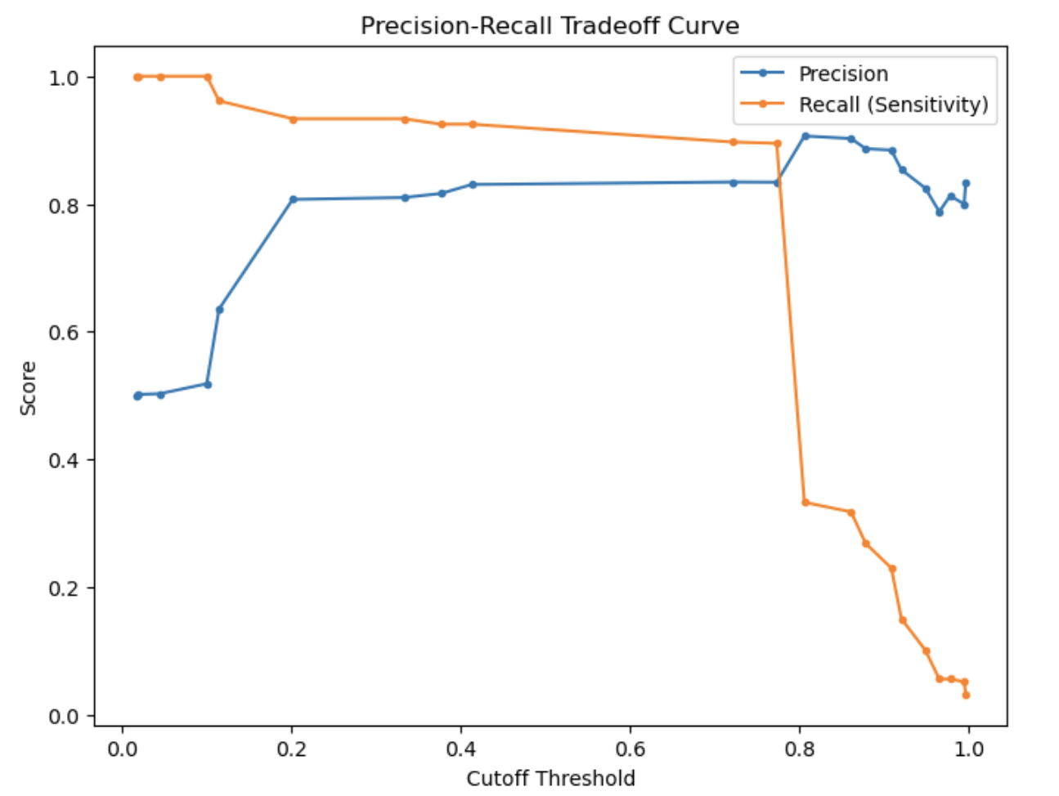

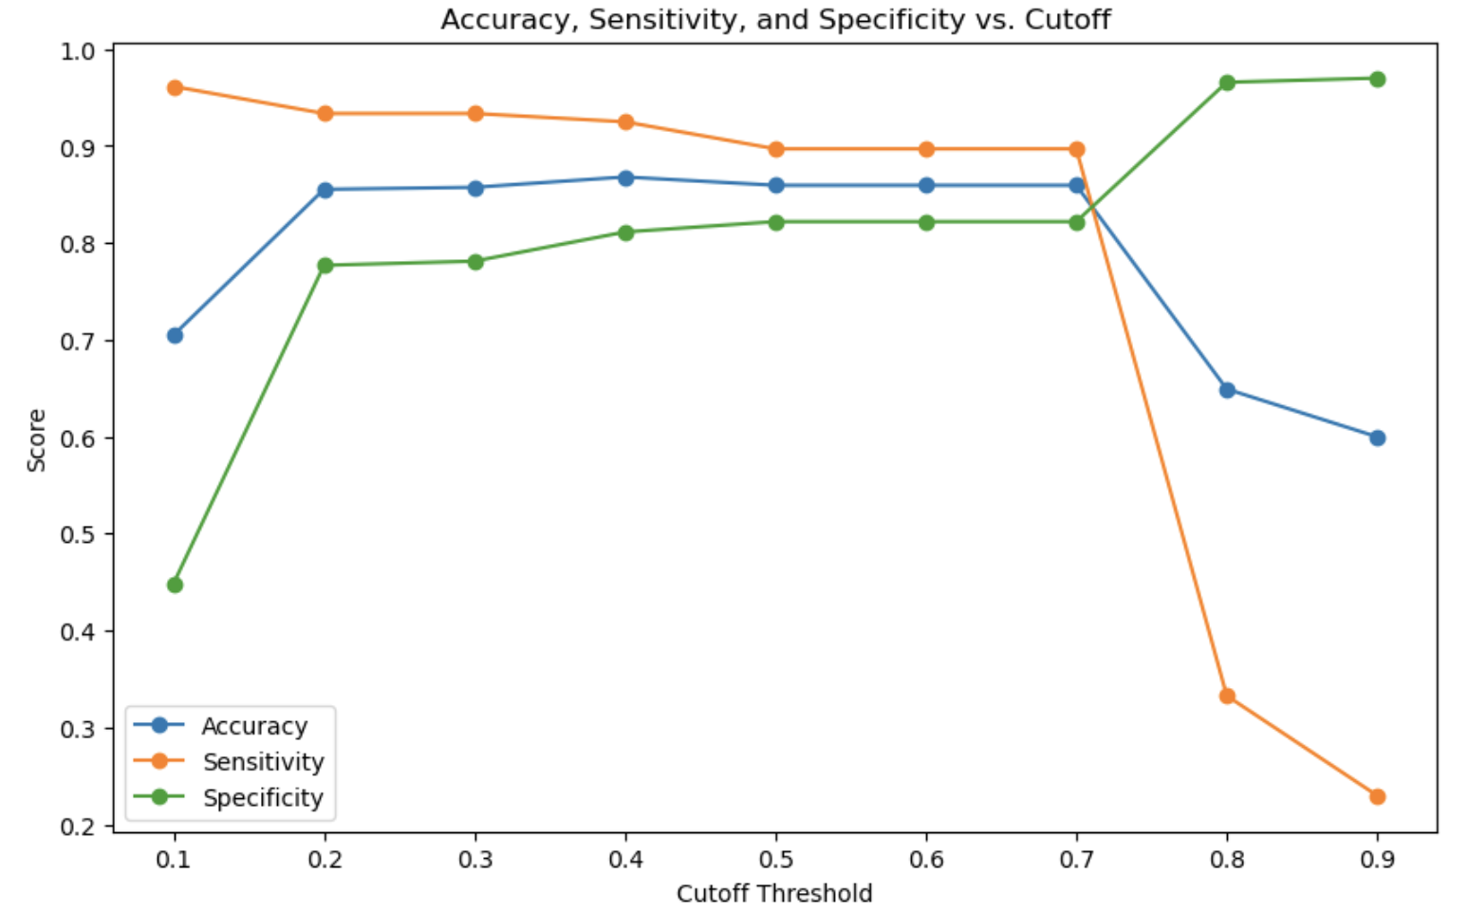

**✅ Random Forest**

* Initial results showed very high overfitting and by using Gridsearch CV we got a confirmation that hyperparameter tuning is required
* Gridsearch CV results

|  |
| --- |
| Cross-Validation Scores: |
| [0.89839572 0.9144385 0.92473118 0.89247312 0.93548387] |
| Mean CV Accuracy: 0.9131 |

* After hyperparameter tuning we got these results -
* max_depth: 10
* min_samples_leaf: 1
* min_samples_split: 2
* n_estimators: 200
* Best Cross-Validation Accuracy: 0.9034
* Results of the model on training data after Hyperparameter tuning

|  |  |  |
| --- | --- | --- |
| **Metric** | **Before Tuning** | **After Tuning** |
| Accuracy | 1 | 0.9796 |
| Precision | 1 | 0.9627 |
| Recall | 1 | 0.9979 |
| Sensitivity | 1 | 0.9979 |
| Specificity | 1 | 0.9614 |
| F1 Score | 1 | 0.9800 |

* Following features are finalized –

|  |  |  |
| --- | --- | --- |
| **Feature List** | | |
| incident_severity_Minor Damage | incident_severity_Total Loss | injury_ratio |
| total_claim_amount | vehicle_claim | vehicle_ratio |
| insured_hobbies_chess | policy_annual_premium | incident_dayofweek |
| property_claim | injury_claim | incident_month |
| months_as_customer | incident_hour_of_the_day | property_ratio |
| age | policy_bind_year | insured_hobbies_cross-fit |
| witnesses | bodily_injuries |  |

## **7. Model Performance (Validation Set)**

|  |  |  |
| --- | --- | --- |
| **Metric** | **Logistic Regression (cutoff=0.4)** | **Random Forest (tuned)** |
| Accuracy | 86.80% | 83.20% |
| Precision | 64.30% | 66.30% |
| Recall | **87.50%** | 73.60% |
| Specificity | 82.60% | **86.60%** |
| F1 Score | **74.10%** | 69.70% |

## **8. Final Recommendation**

We recommend deploying the **Logistic Regression model (cutoff = 0.4)** due to:

* Higher recall (captures more fraudulent claims)
* Simpler, interpretable model
* Balanced trade-off between sensitivity and specificity

The model can be used to **flag high-risk claims for manual review**, improving fraud detection rates and reducing financial loss.

### **Q1: How can we analyse historical claim data to detect patterns that indicate fraudulent claims?**

We used **Logistic Regression** and **Random Forest** to analyze labeled historical claim data.

Key steps included:

* Selecting **important features** that contribute most to fraud detection.
* Applying **resampling techniques** to address class imbalance and ensure fair model training.
* Measuring performance using **recall, precision, and F1 score** to assess fraud detection accuracy.

By comparing both models' responses to past claims, we identified **features** which correlate with fraudulent activity. This helped refine fraud detection

### **Q2: Which features are the most predictive of fraudulent behaviour?**

From model training and importance analysis of the Logistic Regression model, the most predictive features included:

* + insured_hobbies_chess
  + insured_hobbies_cross-fit
  + insured_hobbies_video-games
  + incident_severity_Minor Damage
  + incident_severity_Total Loss
  + incident_severity_Trivial Damage
  + Auto_model_92x

### **Q3: Based on past data, can we predict the likelihood of fraud for an incoming claim?**

Yes, using historical insurance claim data, we trained models that can estimate the probability of a claim being fraudulent. Both the Logistic Regression and Random Forest models give us a probability score, which we can use to decide whether a new claim is likely fraud or not, based on a selected threshold.

In our evaluation, recall (or sensitivity) was important, since in fraud detection it's more critical to catch as many fraud cases as possible, even if it means flagging a few genuine claims by mistake.

The Logistic Regression model, when using a threshold of 0.4, gave us a recall of 87.5%, meaning it correctly identified most of the fraudulent claims. On the other hand, the Random Forest model had a lower recall of 73.6%, which means it missed more fraud cases—even though it was a bit more precise and had higher specificity.

Considering this trade-off, we chose Logistic Regression for fraud prediction. It:

* Catches more fraud cases,
* Has a better balance between precision and recall (F1 score = 74.1%), and
* Is simpler and faster to deploy in real systems.

**Q4: What insights can be drawn from the model that can help in improving the fraud detection process?**

Logistic Regression works better for fraud detection since it catches more fraudulent cases with higher recall.

Random Forest is more precise, but it tends to miss fraud cases, making it less useful in situations where missing fraud is risky.

Adjusting the cutoff from 0.5 to 0.4 for Logistic Regression improves fraud detection by striking a balance between recall and specificity.

The most important features identified can be used to improve screening and fraud detection systems.